*************************

Example of Supporting Documentation for Teaching: A Course Portfolio
Sue Donym
Assistant Professor, School of Education

*************************

This packet of materials is excerpted from a more complete sample portfolio that includes evidence from three sources: the instructor being evaluated, peers, and students. The sample portfolio is a compilation and adaptation of materials from multiple faculty members. The material excerpted into this packet is meant to provide an illustration of the sorts of supplemental documentation an instructor might use to represent their teaching at the course level (although feedback from students and peers is referenced in the instructors’ narratives). It includes the following documents:
Supporting Documentation- Undergraduate Course Portfolio on EPSY 305
  - Course Narrative- Page 2
  - Syllabus- Pages 3-5
  - Sample Assignment and Evaluation Criteria (Rubric)- Pages 6-7
  - Summary of Student Performance- Page 8
  - Sample Instructional Activity aligned with assignment- Pages 9-10

A full teaching portfolio and other materials can be found in a
google folder that is accessible through the above QR code
or this URL: https://tinyurl.com/288ya87j

2A. Sample Course Narrative
Course Narrative- EPSY 305
Sue Donym
Assistant Professor, School of Education

EPSY 305 is a large enrollment (150 students) sophomore/junior level course that enrolls mostly education majors. The course is designed to familiarize students with major theories, big issues and research findings in the field, and help them learn how to apply evidence from the child development literature to issues in educational practice (see the Syllabus for the course learning outcomes). I will highlight a few key approaches I use to support student learning and belonging.
First, because I know so many of my students will be going on to become teachers rather than psychologists, I have developed many examples, exercises and assignments that focus on the educational applications of the material. For example, students complete two “controversial issue” assignments in which they use research on child development to take a stance on a controversial child development issue related to education (e.g., should schools encourage parents to delay kindergarten if their children are young for their grade?). To give them more practice with the needed skills, the first assignment is a group presentation, and a second one they complete individually as a paper (see Sample Instructional Activity).
Second, I use rubrics to identify different dimensions of the main writing assignments. This has enabled me to be transparent about my expectations and provide targeted feedback to students about what they did well and where they need to improve. This approach also helped me see that in earlier offerings of the course, students were doing reasonably well summarizing the issue and with writing quality but they struggled to develop clear arguments for their stance that were actually supported by evidence in the readings. In the last few years I have added more in-class activities to help them learn how to do this (see Sample Instructional Activity), and their demonstration of these skills has really improved. Last year, 80% of my class scored “good” or “excellent” on argument and evidence (see Summary of Student Performance).
Third, I incorporate active learning exercises into each class period, to break up the lecture and to give students a chance to discuss and apply the material (see Sample Instructional Activity). I also added several rapport-building activities. For instance, at the beginning of the term students introduce themselves to the class by creating a slide in a class slide deck posted on Canvas. These changes have really made a difference. Before, the same few students used to answer all of the questions while the remaining just sat there waiting for their friends to provide the answers. Now class engagement has increased markedly, and all students participate in the class discussions and student feedback has been positive. Student ratings have also been increasing every semester.

2B. - Syllabus
UNIVERSITY OF KANSAS
EPSY 305: Development & Learning of the Child
Spring 2022- Monday, Wednesday & Friday 9:00-9:50

Instructor: Prof. Sue Donym
Office hours: Monday 12:00-2:00, Wednesday 10:00-12:00, and by appointment
Office: JRP 632
Email: sue.donym@ku.edu

Course Learning Outcomes. Through this course, students will:
- Become familiar with major theories of child development.
- Evaluate the influences of nature, nurture, and their interaction on children’s outcomes.
- Analyze the role of the sociocultural context in development from the associations between children and their families, peers, society, culture.
- Integrate information about physical, cognitive, social, and emotional development to explain the development of the whole child.
- Apply findings from empirical literature on child development to issues in educational practice.

How to Succeed in this Course:
- Be present in every class, both physically and mentally
- Read the assigned material before class
- Approach readings, lectures, and discussions with an open mind
- Participate actively and thoughtfully in class discussions
- Show respect for others’ ideas and viewpoints

Instructional Mode and Credit Hours. This is an in-person course that fulfills 3 credit hours; consistent with KU policy and the federal definition of a credit hour, this means you should expect to spend at least 9 hours a week on this course over the 15 week semester. Most weeks, 2.5 hours will be class meetings and the remaining time will involve out of class work. On Fridays your class meeting will take place in small discussion sections led by a GTA.

Competencies Promoted by this Course. This course has been designed to meet the following Kansas Educator Preparation Program Standards for Professional Education:
- Standard #1: The teacher understands how learners grow and develop, recognizing that patterns of learning and development vary individually within and across the cognitive, linguistic, social, emotional, and physical areas, and designs and implements developmentally appropriate, relevant, and rigorous learning experiences.
- Standard #2: The teacher uses understanding of differences in individuals, languages, cultures, and communities to ensure inclusive learning environments that enable each learner to meet rigorous standards.

School of Education & Human Sciences Mission. The SOEHS serves Kansas, the nation and the world by (1) preparing individuals to be leaders and practitioners in education and related human service fields, (2) expanding and deepening understanding of education as a fundamental human endeavor, and (3) helping society define and respond to its educational responsibilities and challenges. To accomplish this mission, the SOEHS (1) offers an extensive curriculum leading to degrees and professional licensure, (2) requires faculty and students to engage in scholarship, and (3) provides a wide range of professional services to schools, other institutions, and individuals.

Course Assignments
Exams (45%). There will be three in-class exams, each covering approximately one-third of the course material. Exams will assess your knowledge of material covered in course readings, lectures, and discussions and ability to integrate and apply the material learned in class. Each exam will account for 150 points (15% of your final grade).

Controversial issue presentation (10%). Each student will participate in presentation on a controversial issue in child development related to education (e.g., should we encourage parents to delay kindergarten for children who will be young for their grades?). The presentations will take place in your discussion sections, and will have a panel format. For each topic, a small group of students (3 - 4 students) will be assigned to take the pro side of the issue and a second small group will take the con side. Panel members are expected to present the arguments for their side of the issue clearly and concisely. If a student misses class on a day he or she is scheduled to be a panelist, the student will be asked to help lead a discussion on a topic of the instructor’s choosing later in the semester. The presentation will account for 100 points (10% of your final grade).

Controversial issue report (10%). You will write a short (4 – 5 pages) paper on a controversial issue in child development. Grades will be based on the quality of the argument and supporting evidence, as well as quality of writing. Grades will not be based on the side of the controversy that you choose to support. The CIR will account for 100 points (10% of your final grade).

Developmental milestones guide (20%). For this assignment, you will develop a written guide describing typical development for children of a particular age. The purpose of this assignment is to integrate information about physical, cognitive, social, and emotional development to convey a picture of the whole child. The developmental milestones guide (DMG) will account for 200 points (20% of your final grade).

Attendance and participation (15%). Attendance and participation will be assessed for both the lecture and discussion sections. Grades will be based on attendance, participation in discussion, and the submission of in-class individual and group assignments. Attendance and participation will account for 150 points (15% of your final grade).

Grading Scale
A 925+ points C+ 765 – 794 points
A- 895 – 924 points C 725 – 764 points
B+ 865 – 894 points C- 695 – 724 points
B 825 – 864 points D 625 – 694 points
B- 795 – 824 points F 624 or fewer points

Course Text. How Children Develop (4th edition) by Robert Siegler, Judy DeLoache, Nancy Eisenberg, Jenny Saffran, & Campbell Leaper
Canvas. Announcements, handouts, assignments, readings, and grades will all be posted on a Canvas site for this course. Please check it regularly for important announcements and materials.

Course Policies
Attendance. Students are expected to be present in class both physically and mentally. This means attending class and committing your full attention to the course during the time you are in class. It is up to the student to obtain class material and information missed due to absence.

Deadlines and Exam Dates. Deadlines for assignments are firm. However, we understand that sometimes illness or family issues or life happens, and include details about how to make up work in the assignment descriptions. These opportunities should be treated as an exception, not the rule—you will earn a much better grade in the class if you keep up with the weekly coursework! Students should adjust travel and work schedules to avoid time conflicts with the exams and we expect students to take exams as they are scheduled. Students with medical or other serious reasons must contact the instructor via email before the scheduled exam time to take a make-up.

Diversity and Inclusive Practices, As a premier international research university, KU is committed to an open, diverse and inclusive learning and working environment that nurtures the growth and development of all. KU holds steadfast in the belief that an array of values, interests, experiences, and intellectual and cultural viewpoints enrich learning and our workplace. The promotion of and support for a diverse and inclusive community of mutual respect require the engagement of the entire university. I expect that there will be considerable diversity in the preparation and perspectives of students in this class, and I appreciate and encourage diversity of thought in my classroom. At the same time, it is my goal for all students to experience my classroom as a safe environment. It is likely you may not agree with everything that is said or discussed in the class. When you disagree with someone, please be courteous and respectful- be sure that you make a distinction between criticizing an idea and criticizing the person.

Academic honesty: It is critical that all work submitted for this course represents your own work and efforts. Academic misconduct includes giving or receiving of unauthorized aid on assignments, knowingly misrepresenting the source of any academic work, plagiarizing of another's work, disruption of classes, threatening an instructor or fellow student, or otherwise acting dishonestly in scholarship or research. If you are unsure about what constitutes unauthorized aid or plagiarism on an assignment, please contact the course instructor or a GTA. Evidence of academic misconduct on an assignment will result in a failing grade on the assignment and a report of academic misconduct being filed. Further information about School of Education academic misconduct policies can be found at http://policy.ku.edu/soe-student-academic-misconduct-policy.

Contacting the instructor and GTAs: The instructor and GTAs are available to answer any questions you have about the course. Most of the time, email will be the best way to get in touch with us; we will make every attempt to respond within 24 hours (not including weekends). To facilitate a prompt response, please include the phrase “EPSY 305” in the subject line of all emails.

Students with disabilities / English language learners: Please speak with me if you require accommodations due to a disability or because you are learning English. For more information about accommodations for students with disabilities, contact the Academic Achievement and Access Center (http://access.ku.edu/).
2C. Sample Assignment
EPSY 305- Spring 2022
Controversial Issue Report Assignment

Learning goals
- Explore a current controversy related to child development and education
- Use evidence to support an argument
- Integrate and synthesize information from multiple sources in a coherent manner
- Present information on an important topic in an understandable and engaging manner

For this assignment, you are to take the perspective of a consultant to a school or school system, to help them make a decision about a current controversy in child development related to education. First, you will read a series of journal articles describing your chosen controversy. Some of the articles will argue for a particular position, whereas others will take a more balanced view of the issue. Based on the readings, you will write a 4 - 5 page paper making an argument for one side of the controversy. Papers will be due in class on April 15.

Topics. This year’s controversies are:
- Sleep and School start times. Elementary, middle and high schools in the same district have staggered starts so they can share buses. This controversy is about which age group should start school the earliest: elementary school children, or middle and high school children (i.e., adolescents)? The readings focus on the relationship between sleep and cognitive development and academic performance at different ages.
- Academic Redshirting. In the US context, it has become common practice for affluent parents to delay kindergarten if their children are born close to the “cutoff” date for their grade, and some school staff encourage this practice. Yet others argue that a year off just delays school enrichment. Should schools encourage academic redshirting?
- Recess and Learning. Under pressure to cut costs and improve tests scores, many schools have reduced or eliminated recess and physical education in elementary school so as to increase instructional time. Other experts argue that taking a break and getting exercise can actually help children learn. Should recess and physical education be eliminated or not?
For each topic, you will find five journal articles posted in Canvas.

Paper Guidelines
Your paper should include a summary of the topic, a clear statement of your opinion on the controversy, a discussion of the supporting evidence for your position (why do you support your chosen position), and a discussion and refutation of the evidence for the other position (why do you not support the other position, given the evidence for it).

Evidence to support your argument may be drawn from the journal articles for your chosen topic posted to Canvas, the course textbook, and class lectures and discussions. When you are searching for evidence to support your argument, remember that a research study that is based on responses from many people is much stronger than a story that is about one person. Knowing something about a single person does not tell us much about how an issue will affect other people.

Your paper should reflect your own work. This means that you should take the information you obtain from sources and put it into your own words, and give credit to authors (using in-text citations) when you use their ideas. Your paper should include a reference list formatted in APA style. Direct quotations should be used rarely, if at all (more than two direct quotations in your paper is too many). Any passage taken directly from a source should be placed within quotation marks and attributed to the author (using APA style). Quoting from a source without attribution is considered plagiarism and is a violation of KU’s policies on academic honesty.

Grades will be based on the quality of your argument and the quality of the evidence you use to support your argument. The clarity of your writing (including use of correct spelling and grammar) will also be a part of your grade. See rubric below for more information on how papers will be evaluated.
Controversial Issue Paper Rubric
Paper Dimension | Unsatisfactory | Marginal | Good | Excellent
Summary of Topic  20 pts total | Minimal summary of issue. Many key elements are missing, or summary is disorganized | Some key elements are addressed; Summary of issue is moderately organized; some points are unclear or confusing. | Most key elements of issue are addressed. Paper includes clear and concise summary of issue. | All key elements of issue are addressed. Summary of issue is thorough and thoughtful.
Argument  15 pts total | Paper does not clearly state which side of the argument is being supported. No attempt to tie argument to evidence. | Paper clearly states argument being supported. Relations of evidence to argument are unclear or missing. | Paper clearly states argument being supported. Some ties between argument and evidence. | Paper clearly states argument being supported. Paper clearly ties evidence to argument.
Supporting Evidence  40 pts total | Little supporting evidence is presented; includes multiple factual inaccuracies; does not address opposing argument | Some evidence is presented; readings are used to support central argument, but not extensively. Some factual inaccuracies. Minimal discussion of opposing arguments. | Presents multiple pieces of supporting evidence, uses multiple sources; Only minor inaccuracies. Addresses opposing argument but does not include evidence to refute it | All provided sources of supporting evidence are used. All information is accurate. Addresses and refutes opposing argument.
Writing Quality  25 pts total | Difficult to follow. Writing errors impede under-standing. Poorly organized; logic of argument is hard to follow. Too many direct quotations.  No use of in-text citations. Missing references | Writing is inconsistent. Some unclear sections. Some problems with organizational structure. Overuse of quotations. Reference list is present, but is missing citations or has many errors in formatting. | Generally well-written. Some grammatical errors but do not interfere w/comprehension. Clear organization and clear transitions. Minor errors in citations and/or references. | Well-written. Clear and easy-to-read. Only minor grammatical errors. Organization and transitions contribute to argument. Citations are clear and references conform to APA style.
2D. Summary of Student Performance
Student Learning Data- Controversial Issues Paper
Spring 2018 |  |  | % of Students at each mastery level
Rubric element | Possible points | Avg. score | Unsatisfactory | Marginal | Good | Excellent
Summary of topic | 20 | 16.9 | 0% | 20% | 45% | 35%
Argument | 15 | 10.3 | 2% | 50% | 35% | 13%
Supporting evidence | 40 | 29.8 | 2% | 48% | 40% | 10%
Quality of writing | 25 | 21.0 | 0% | 10% | 61% | 29%

Spring 2020 |  |  | % of Students at each mastery level
Rubric element | Possible points | Avg. score | Unsatisfactory | Marginal | Good | Excellent
Summary of topic | 20 | 17.6 | 0% | 18% | 47% | 35%
Argument | 15 | 10.9 | 3% | 47% | 35% | 15%
Supporting evidence | 40 | 25.5 | 12% | 54% | 26% | 8%
Quality of writing | 25 | 19.0 | 0% | 25% | 62% | 13%

Spring 2022 |  |  | % of Students at each mastery level
Rubric element | Possible points | Avg. score | Unsatisfactory | Marginal | Good | Excellent
Summary of topic | 20 | 17.8 | 0% | 12% | 40% | 48%
Argument | 15 | 14.2 | 0% | 18% | 42% | 40%
Supporting evidence | 40 | 34.8 | 0% | 20% | 50% | 30%
Quality of writing | 25 | 19.0 | 0% | 8% | 60% | 32%

2E. Sample Instructional Activity
EPSY 305
In-Class Activity: Sociocultural Factors Related to Reasoning and Problem Solving
This exercise asks you to examine evidence generated from research on reasoning and problem solving to draw conclusions about the factors that influence the development of reasoning and problem solving.
Solis & Callahan (2016) were interested in the sociocultural factors related to children’s scientific reasoning. They studied parent and child interactions about science problems among Mexican heritage families who had either Basic Schooling (did not complete high school) or Higher Schooling (high school degree or college). Below are excerpts of evidence collected from each type of dyad.
Basic Schooling Dyad Example:
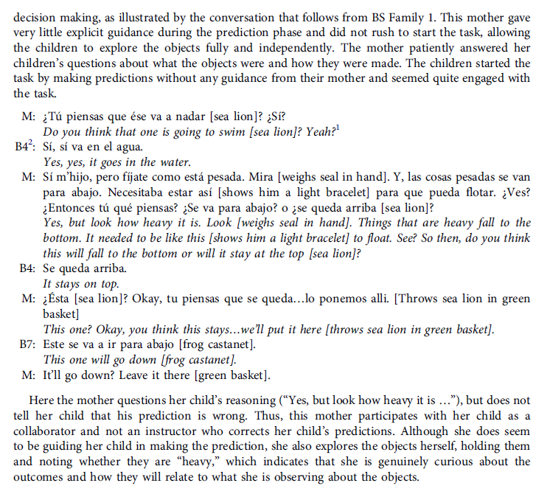
Higher Schooling Dyad Example: 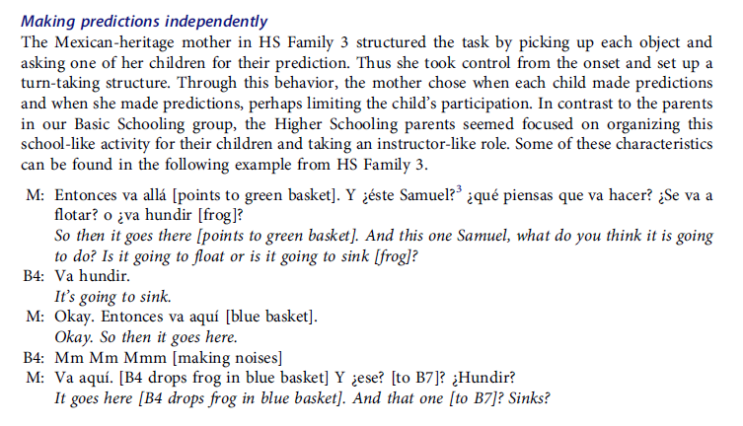
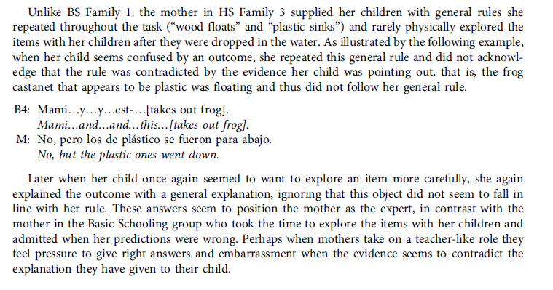
- Review the examples and discuss differences and explanations: What differences do you observe in the parents’ behaviors? What might account for these patterns? What differences do you observe in the child’s behaviors? What might account for those?

- Predictions. If you did a follow-up study of later, independent scientific problem solving in these children, what sorts of differences do you think you might observe? What types of science tasks or activities do you think children from each group will be best prepared for?

